

**8th Annual Great Lakes Indigenous Farming Conference**

**March 3-7, 2011**

**Maplelag Resort, White Earth Reservation, MN**

**Hosted by: White Earth Land Recovery Project**

**Maawanji’idiwag Ji Gizhaadamowaad Miinkaanan**

**‘They Are Gathering To Protect the Seeds’**

**Discussion & Workshops:**

**Pesticide Drift, Bee Colony Collapse, Update on 1855 Treaty, Wild Rice & Sulfide Mining, Anishinaabe History Workshop, Slow Foods & More**

**Conference Fees**

**Do Not Include Lunch**

**Full Rate: $50**

**Day Rate: $25**

**Youth: $10**

**Lodging**

**$240=3 nights**

**Meals Included**

**Full Conference Fee**

**Communal Cabin - Bring Sleeping**

**Bags & Towels**

**Ski Rental Available**

**www.welrp.org**

**March 3, 2011**

**@ 6 pm**

**Native Harvest presents:**

**A “Slow Food” Dinner**

**Featuring ‘Wild Rice’**

**March 4, 2011**

**Workshops on Wild Rice Preservation, Sulfide Mining, and Domestic Fair Trade Association.**

**March 5, 2011**

**Farm to School Programs Workshop Hosted By Guy Wolf, Producers for Farm to School Programs - Local Growers**

**Scholarships Available**

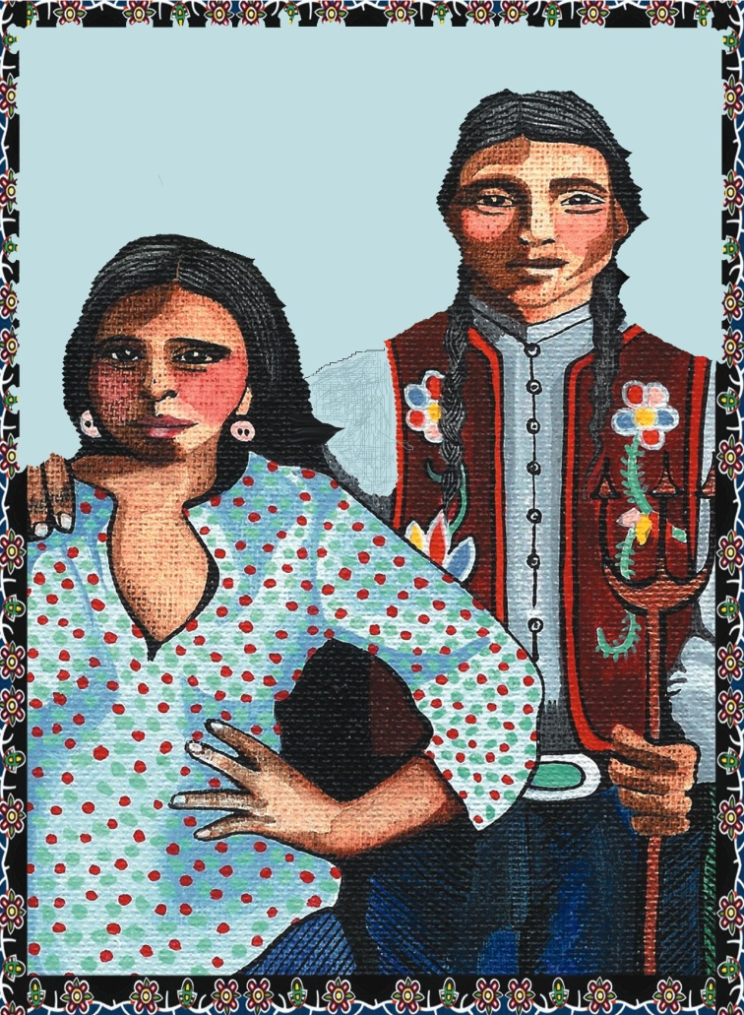

**For information contact: White Earth Land Recovery Project**

**Karla Bellanger, 218.375.2600** [**events@welrp.org**](mailto:events@welrp.org)

**Conference Lodging: Maplelag Resort, 1.800.654.7711** [**www.maplelag.com**](http://www.maplelag.com)

